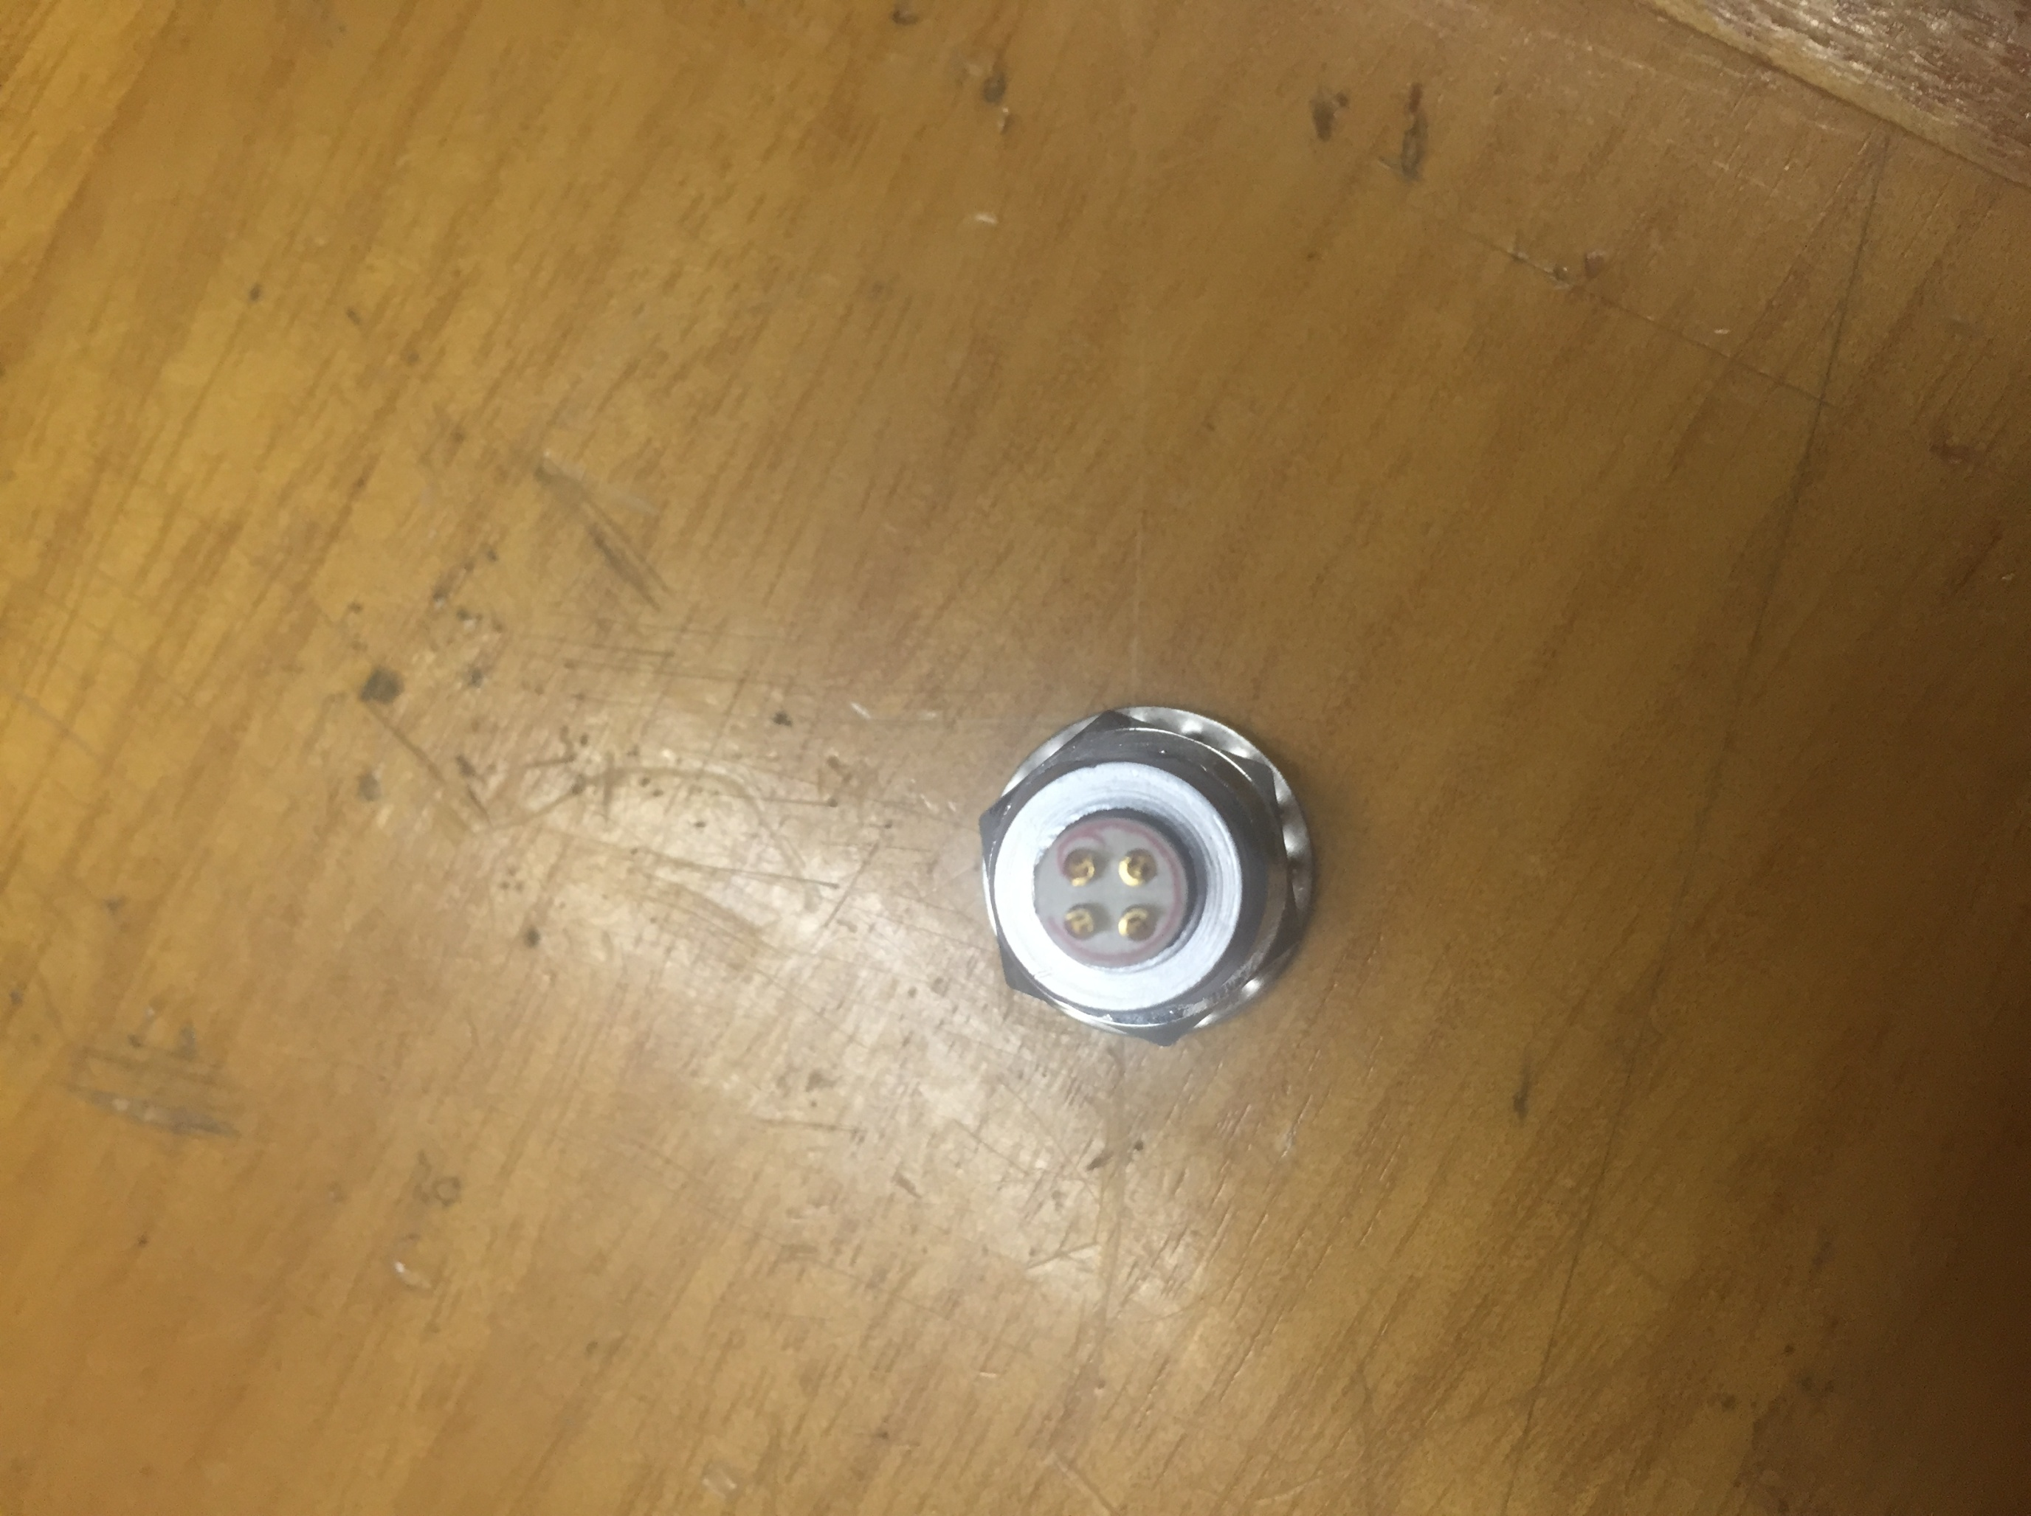

Weld the blue line at this point.

See that there is a red circle around the copper welding point. weld the red line at this point.

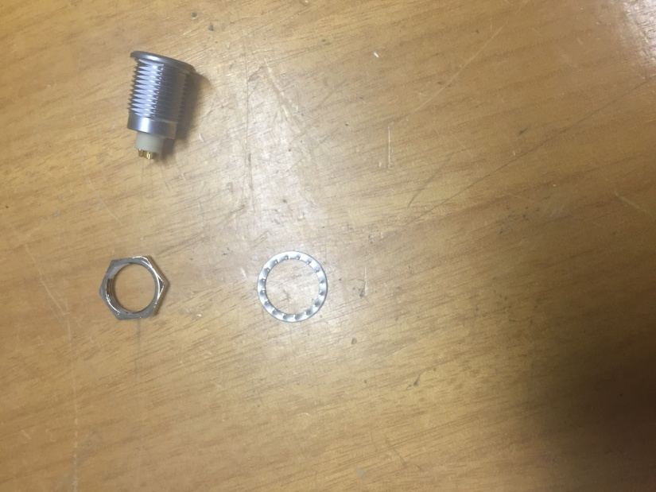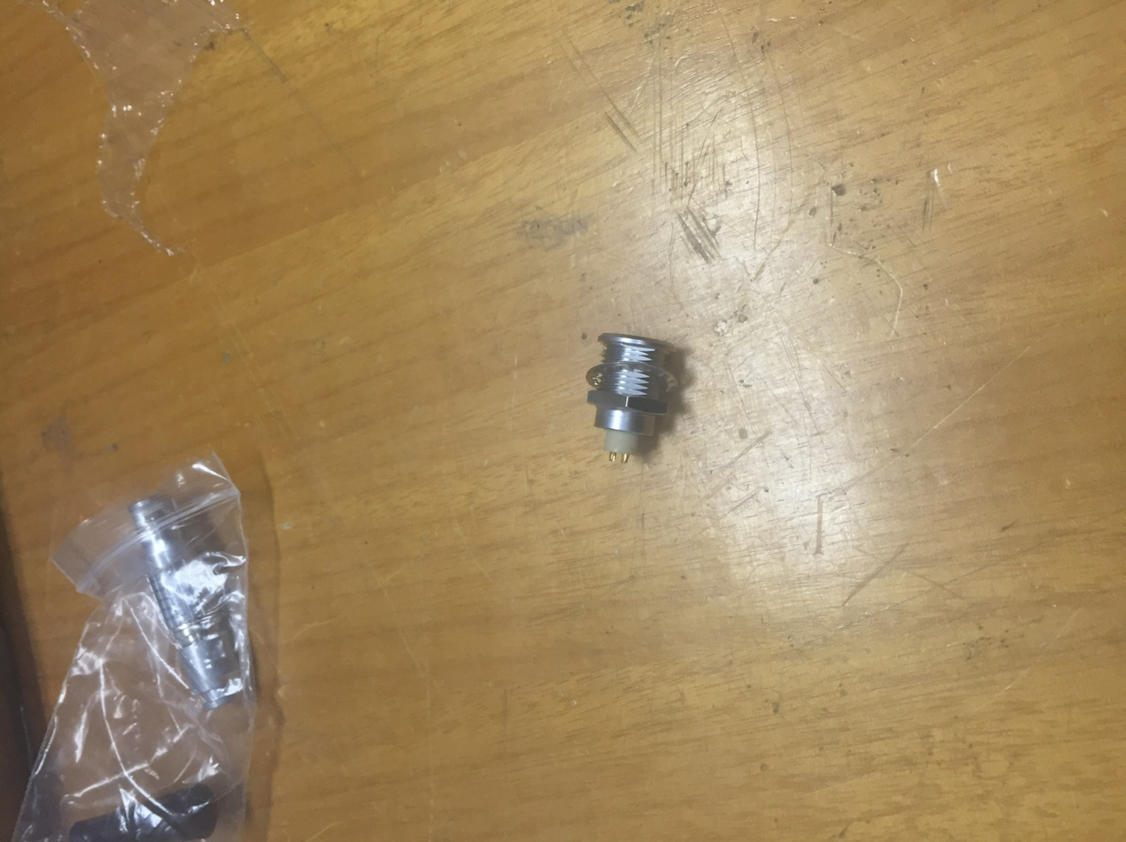

Weld the black line on the iron ring.