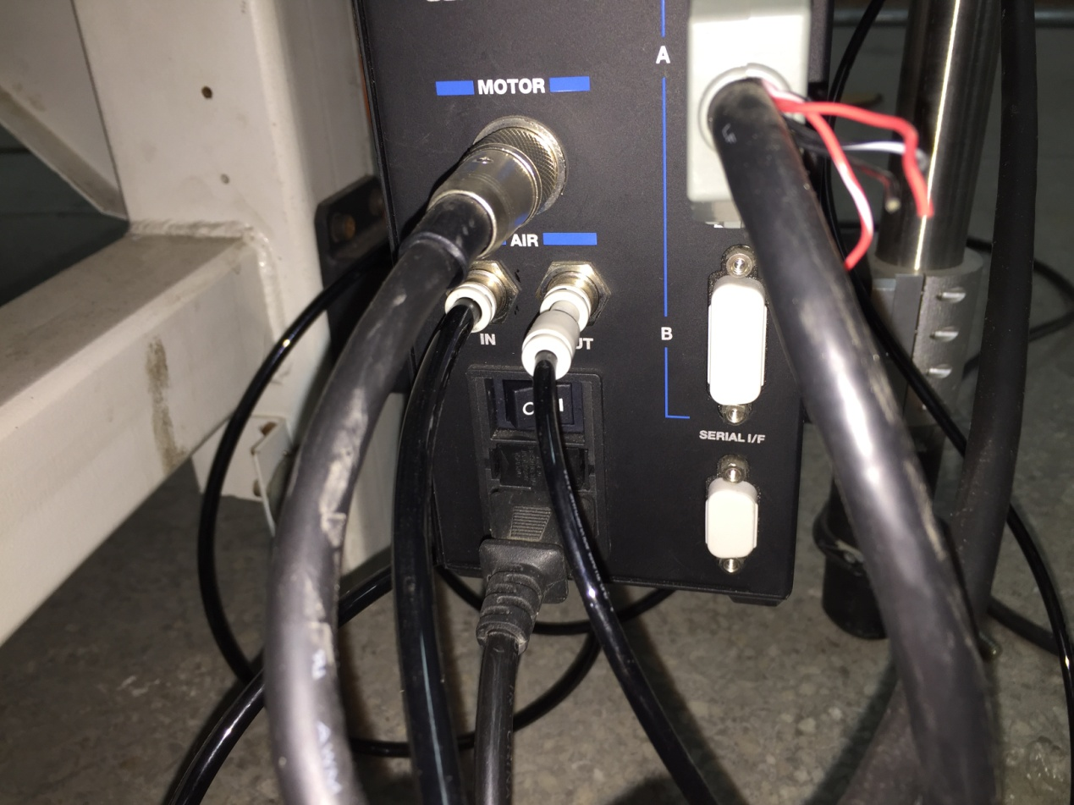Router and safety device installation

1. electric line and air tube connection of router driver

Data line from C board of machine

Control line to router

Power line

Compressed air out

Compressed air in

2、air device and air tube connection.

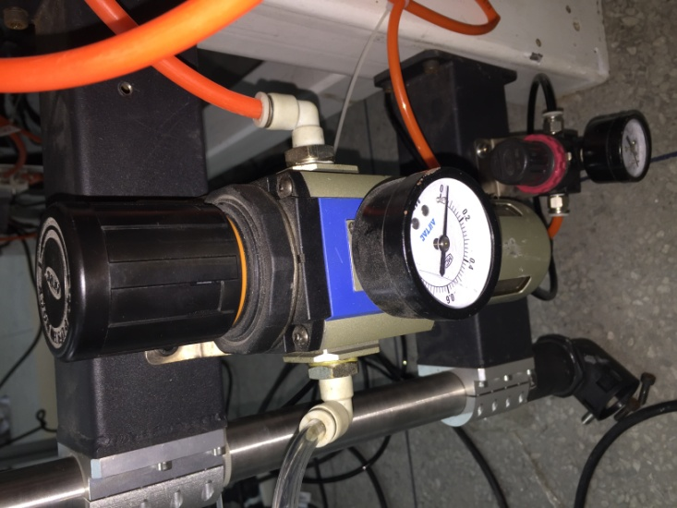

Tube4.compressed air to router driver

Tube2.compressed air from air processing device

Tube3.compressed air from air processing device

Tube1.

Compressed air from outside

Pressure meter

Tube2.Compressed air to pressure meter

Air processing device

3、C board on machine connection

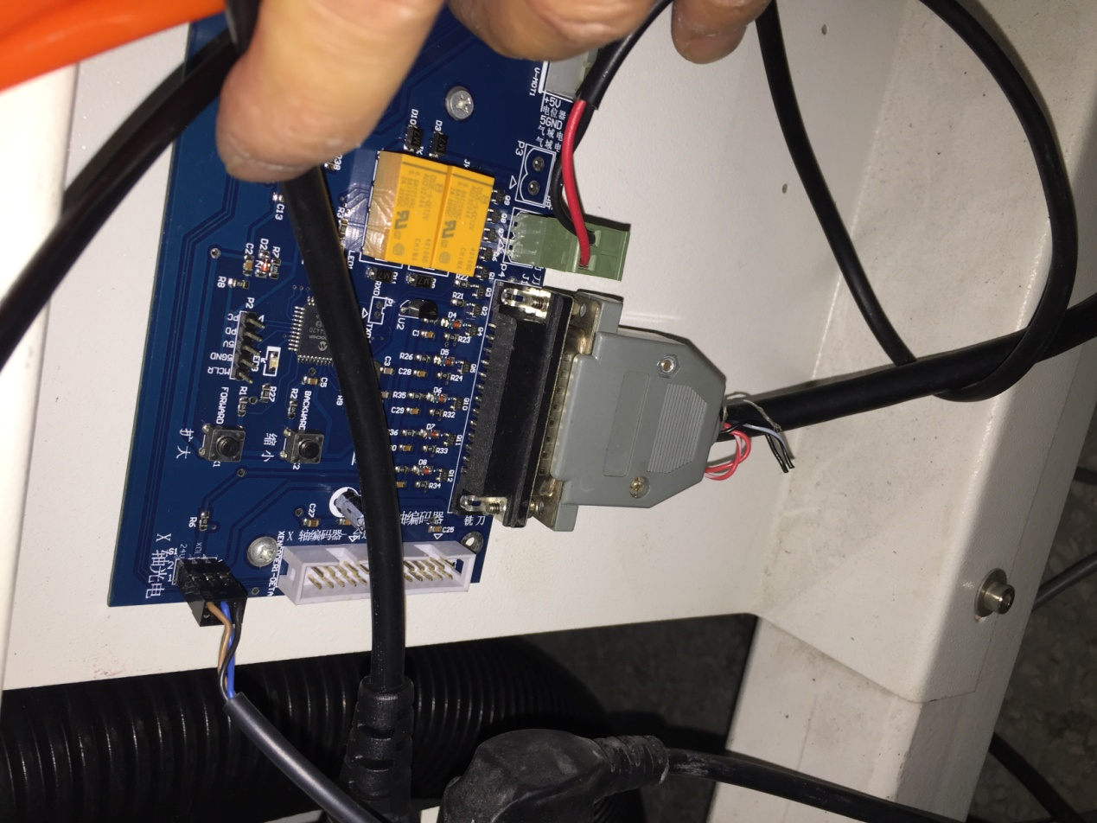

Data line from router driver

**Safety device installation**

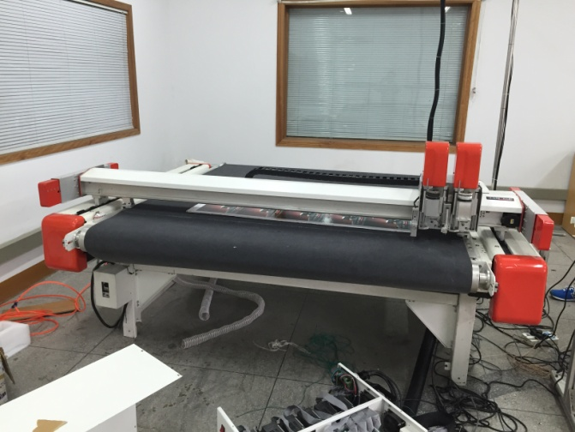

Right device

Left device

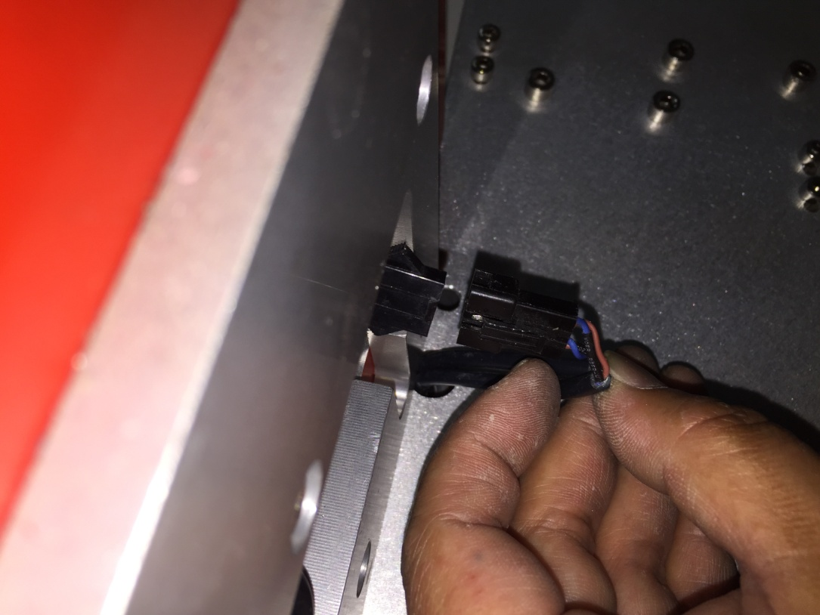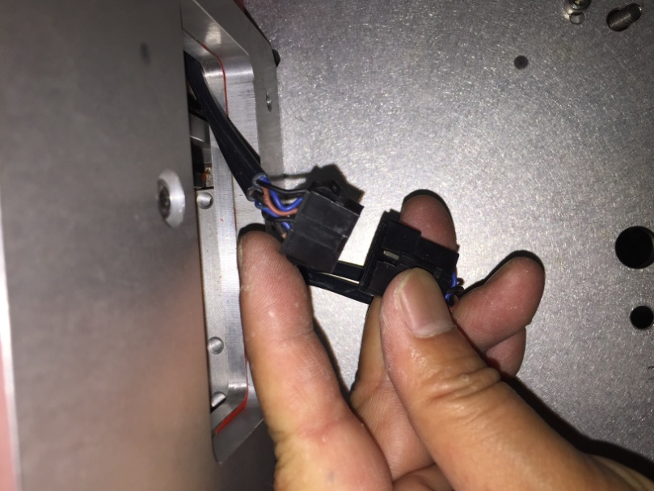

Four tiny lines

Six tiny lines

Left device

right device