**Electric lines connections with control box**

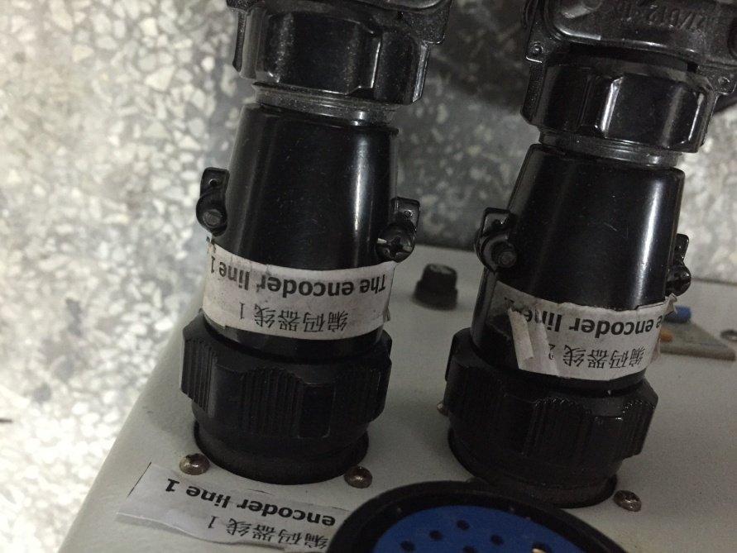1、connect encoder line 1 and 2 with control box

2、connect power line with control box

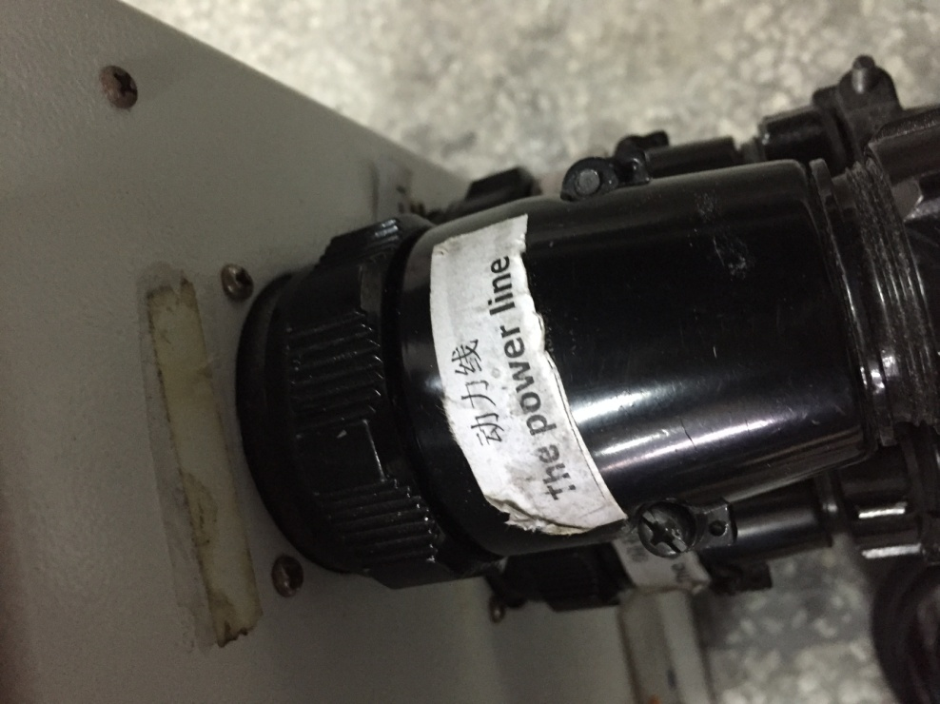

3、connect “pause” line、vacuum pump line and AKI line with control box

“pause” line

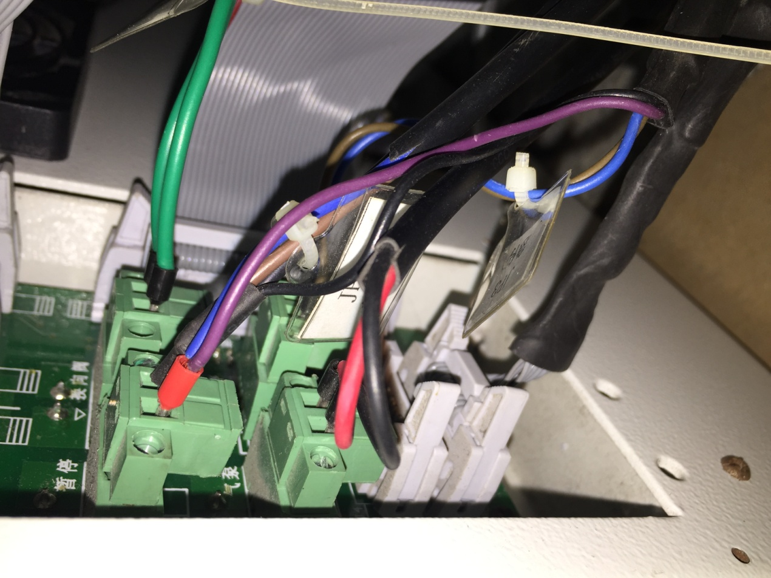

AKI line

vacuum pump line

4、connect ‘s71-1’,’s7-2’,’s9-1’,’s9-2’ and ‘ master’ data lines with control box

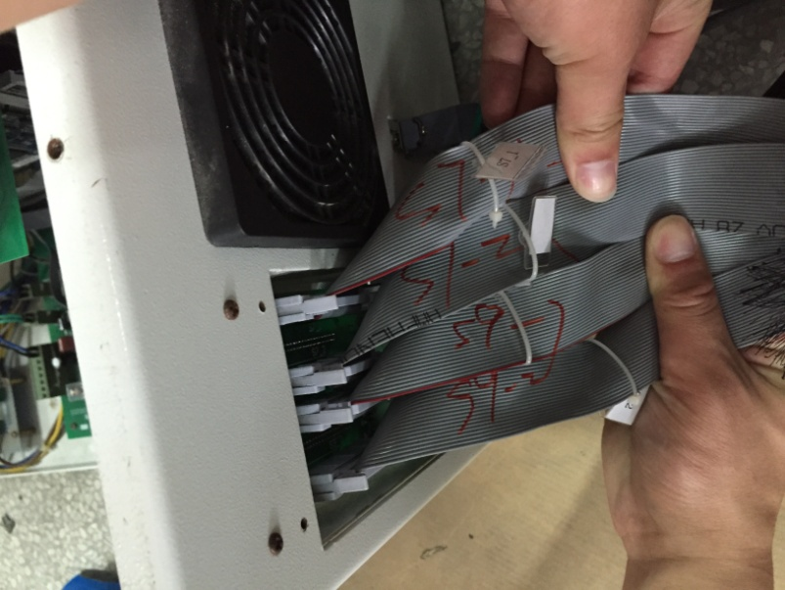

S9-2

S9-1

S7-2

S7-1

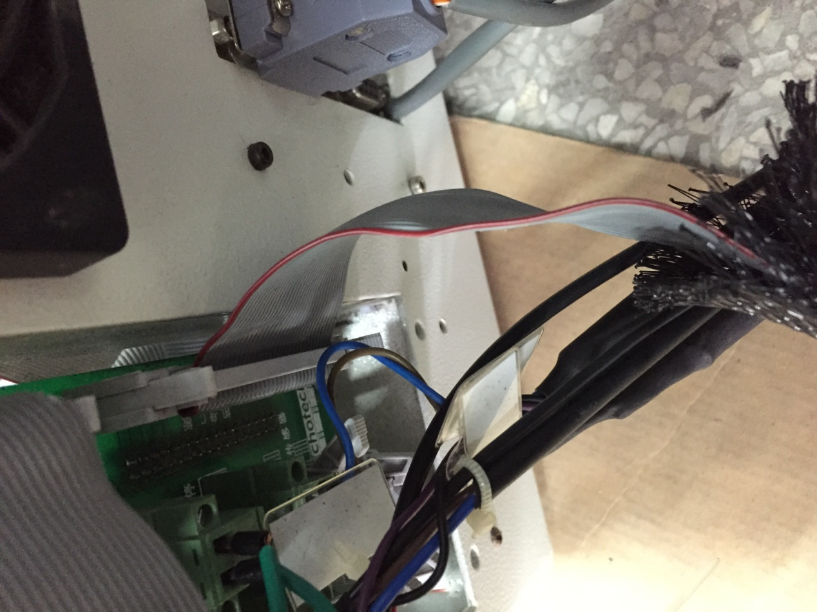

‘master’data line

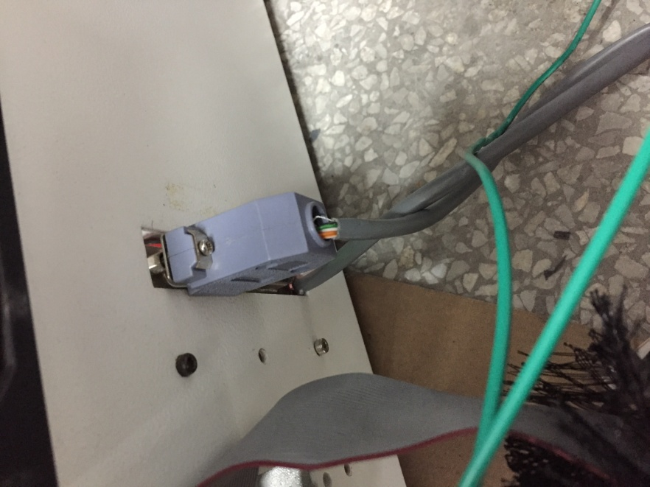5、connect pci serial line with control box

pci serial line